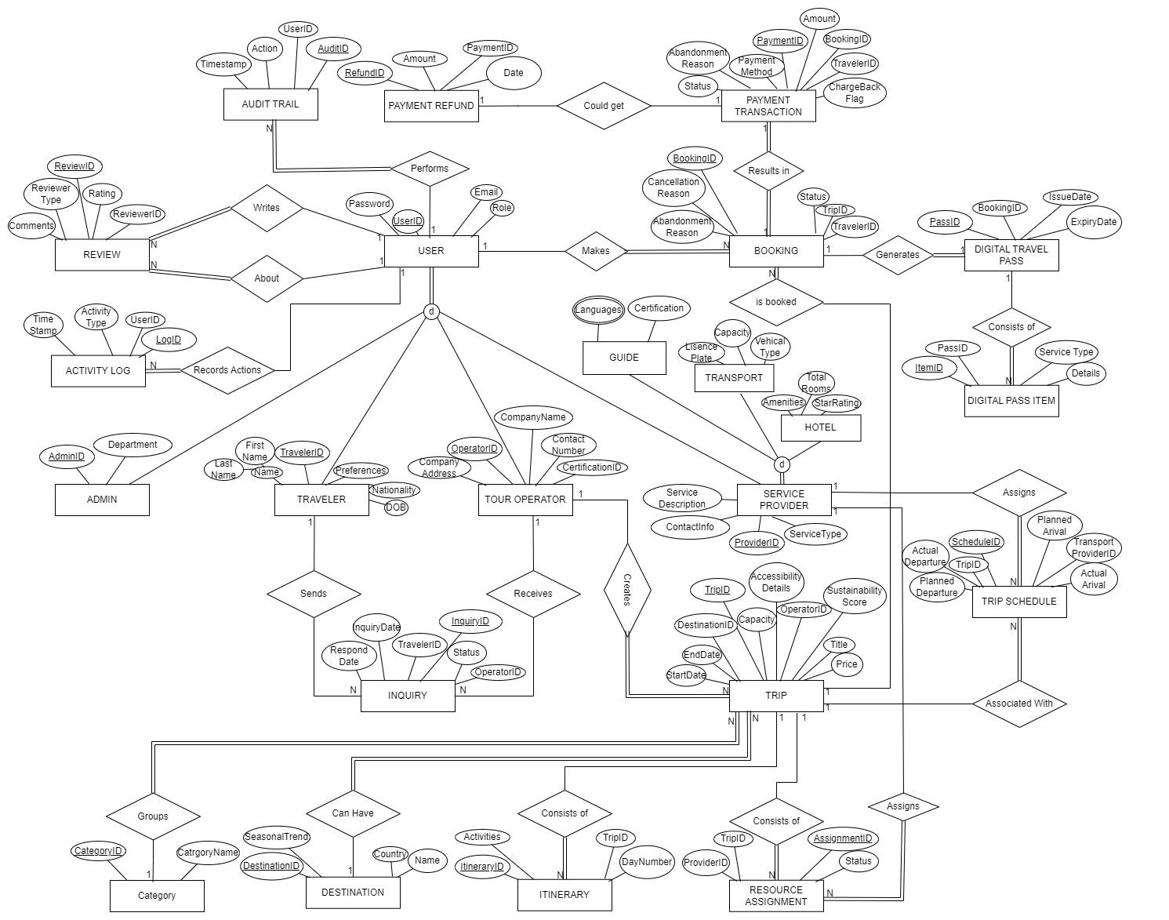
Documentation for Project:
ERD:
TravelEase Schema: 3NF Normalization & Entity Consolidation
This document walks through the normalization of the TravelEase schema up to Third Normal Form (3NF), then proposes entity consolidations to reduce overall table count without losing functionality.
1. Starting Point (Post-ERD Schema)
- ~30 tables covering Users, specializations, Trips, Bookings, Payments, Reviews, Assignments, Logs, Schedules, Passes, Tickets, etc.
Key design goals:
- Eliminate redundancy and update anomalies (3NF)
- Preserve all reported queries & features
- Reduce # of entities by merging closely related tables

Step 1: First Normal Form (1NF)
- Atomicity: Ensure every attribute holds only one value.
  - All composite or repeating fields (e.g., languages in Guides, comma-list) are moved to child tables if needed (e.g., guide_languages(guide_id, language)).
- Unique rows: All tables have a primary key.
No major violations existed: all current tables have scalar columns and PKs.

Step 2: Second Normal Form (2NF)
- Eliminate Partial Dependencies: In any table with a composite primary key, ensure non-key attributes depend on the whole key.
  - E.g., in an earlier design booking_details(booking_id, trip_id, traveler_count, total): attributes moved into bookings keyed solely on booking_id.
All current tables use single-column PKs, so 2NF is already satisfied.

Step 3: Third Normal Form (3NF)
- Remove Transitive Dependencies: No non-key attribute should depend on another non-key attribute.
Table | Transitive Issue | Resolution
users | is_approved depends on user_type logic? | OK: semantics not domain data
payments | none (refunds were separate) | refunds moved into payment_refunds
service_providers | none | –
trip_categories | none | –
hotel_bookings | duplicated status semantics vs trip_services | merged into generic assignments
All other tables hold only attributes dependent on their PK.

Entity Consolidation Proposals
To simplify management, we group highly related tables under polymorphic or unified structures:
Original Tables | Consolidated Table | Rationale
support_tickets, inquiries | tickets | Merge general support and operator Q&A; add type = {'support','inquiry'}.
payments, payment_refunds | payments | Move refund fields (refund_amount, refund_date) into payments.
activity_log, audit_trail | system_logs | Single log table with log_type: {'activity','audit'}.
hotel_bookings, trip_services, trip_guides | trip_assignments | Generic assignment: assignment_type: {'hotel','service','guide'}.
This reduces table count by 4 while preserving all attributes and relationships.

Final 3NF Schema (Consolidated)
Below is the streamlined list of entities, their PKs, and major FKs.
- users (id)
- tour_operators (id → users.id)
- service_types (id)
- service_providers (id → users.id, service_type_id → service_types.id)
- transport_providers (provider_id → service_providers.id)
- tickets (id, user_id → users.id, operator_id? → tour_operators.id)
- destinations (id)
- trip_categories (id)
- trips (id, operator_id → tour_operators.id, category_id → trip_categories.id, destination_id → destinations.id)
- itineraries (id, trip_id → trips.id)
- bookings (id, trip_id → trips.id, user_id → users.id)
- payments (id, booking_id → bookings.id)
- reviews (id, user_id → users.id)
- trip_schedules (id, trip_id → trips.id, transport_provider_id → service_providers.id)
- digital_travel_passes (id, booking_id → bookings.id)
- digital_pass_items (id, pass_id → digital_travel_passes.id)
- system_logs (id, user_id → users.id)
- trip_assignments (id, trip_id → trips.id, provider_id → service_providers.id)
- wishlists (id, user_id → users.id, trip_id → trips.id)
- trip_images (id, trip_id → trips.id)
Specializations:
- tour_operators, service_providers, transport_providers remain separate for clarity.
- tickets.type (support vs inquiry) and trip_assignments.assignment_type (hotel/service/guide) cover former sub-tables.
Benefits of This Design
- 3NF Compliance: No partial or transitive dependencies.
- Reduced Table Count: ~~30→20.
- Full Feature Coverage: All original attributes and query paths preserved via type flags.
- Easier Maintenance: Fewer tables, unified logs/tickets/assignments.

Relational Model: Post-Normalization Schema
Below is the complete relational model for TravelEase after 3NF normalization and consolidation. Each relation lists its attributes, primary key (PK), foreign keys (FK), and any important domain constraints.

1. users
- Attributes:
  - id INT, PK, IDENTITY(1,1)
  - email VARCHAR(100), UNIQUE, NOT NULL
  - password VARCHAR(255), NOT NULL
  - first_name VARCHAR(50), NOT NULL
  - last_name VARCHAR(50), NOT NULL
  - birth_date DATE
  - nationality VARCHAR(50)
  - phone VARCHAR(20)
  - address VARCHAR(255)
  - user_type VARCHAR(20), NOT NULL, CHECK IN ('traveler','tour_operator','service_provider','admin')
  - profile_pic VARCHAR(255)
  - joined_date DATETIME, DEFAULT GETDATE()
  - is_active BIT, DEFAULT 1
  - is_approved BIT, DEFAULT 0
2. tour_operators
- Attributes:
  - id INT, PK, FK → users(id)
  - company_name VARCHAR(100), NOT NULL
  - license VARCHAR(50)
  - years_active INT
  - description TEXT
  - website VARCHAR(255)
3. service_types
- Attributes:
  - id INT, PK, IDENTITY(1,1)
  - name VARCHAR(50), UNIQUE, NOT NULL
  - description TEXT
4. service_providers
- Attributes:
  - id INT, PK, FK → users(id)
  - company_name VARCHAR(100), NOT NULL
  - service_type_id INT, FK → service_types(id)
  - license VARCHAR(50)
  - description TEXT
  - website VARCHAR(255)
5. transport_providers
- Attributes:
  - provider_id INT, PK, FK → service_providers(id)
  - vehicle_type VARCHAR(50), NOT NULL
  - capacity INT, NOT NULL
  - license_plate VARCHAR(50), NOT NULL
6. tickets
- Attributes:
  - id INT, PK, IDENTITY(1,1)
  - user_id INT, FK → users(id)
  - related_id INT, -- reference to trip, operator, etc.
  - type VARCHAR(20), CHECK IN('support','inquiry'), NOT NULL
  - subject VARCHAR(255), -- for support or inquiry title
  - description TEXT, -- ticket body
  - created_at DATETIME, DEFAULT GETDATE()
  - status VARCHAR(20), CHECK IN('open','in progress','resolved','closed'), DEFAULT 'open'
  - priority VARCHAR(10), CHECK IN('low','medium','high'), DEFAULT 'medium'
  - response_time AS (DATEDIFF(MINUTE, created_at, resolved_at))
  - resolved_at DATETIME
7. destinations
- Attributes:
  - id INT, PK, IDENTITY(1,1)
  - name VARCHAR(100), NOT NULL
  - city VARCHAR(50), NOT NULL
  - country VARCHAR(50), NOT NULL
  - description TEXT
  - climate TEXT
  - best_time VARCHAR(100)
  - popularity DECIMAL(3,2), CHECK BETWEEN 0 AND 5
  - image VARCHAR(255)
8. trip_categories
- Attributes:
  - id INT, PK, IDENTITY(1,1)
  - name VARCHAR(50), UNIQUE, NOT NULL
  - description TEXT
9. trips
- Attributes:
  - id INT, PK, IDENTITY(1,1)
  - operator_id INT, FK → tour_operators(id)
  - category_id INT, FK → trip_categories(id)
  - destination_id INT, FK → destinations(id)
  - name VARCHAR(100), NOT NULL
  - days INT, NOT NULL
  - capacity INT, NOT NULL
  - price DECIMAL(10,2), NOT NULL
  - start_date DATE, NOT NULL
  - end_date DATE, NOT NULL
  - description TEXT
  - inclusions TEXT
  - exclusions TEXT
  - cancel_policy TEXT
  - eco_score DECIMAL(3,2), CHECK BETWEEN 0 AND 5
  - is_active BIT, DEFAULT 1
  - image VARCHAR(255)
  - created_at DATETIME, DEFAULT GETDATE()
10. itineraries
- Attributes:
  - id INT, PK, IDENTITY(1,1)
  - trip_id INT, FK → trips(id)
  - day_number INT, NOT NULL
  - activities TEXT, NOT NULL
11. bookings
- Attributes:
  - id INT, PK, IDENTITY(1,1)
  - trip_id INT, FK → trips(id)
  - user_id INT, FK → users(id)
  - booked_on DATETIME, DEFAULT GETDATE()
  - travel_date DATE, NOT NULL
  - traveler_count INT, NOT NULL
  - total DECIMAL(10,2), NOT NULL
  - status VARCHAR(20), CHECK IN('pending','confirmed','cancelled','completed'), NOT NULL
  - cancellation_reason TEXT
12. payments
- Attributes:
  - id INT, PK, IDENTITY(1,1)
  - booking_id INT, FK → bookings(id)
  - amount DECIMAL(10,2), NOT NULL
  - paid_at DATETIME, DEFAULT GETDATE()
  - method VARCHAR(50), NOT NULL
  - transaction_id VARCHAR(100)
  - status VARCHAR(20), CHECK IN('pending','successful','failed','refunded'), NOT NULL
  - is_chargeback BIT, DEFAULT 0
  - refund_amount DECIMAL(10,2)
  - refund_date DATETIME
13. reviews
- Attributes:
  - id INT, PK, IDENTITY(1,1)
  - user_id INT, FK → users(id)
  - review_type VARCHAR(20), CHECK IN('trip','hotel','service','guide'), NOT NULL
  - reference_id INT, NOT NULL
  - rating INT, CHECK BETWEEN 1 AND 5, NOT NULL
  - comment TEXT
  - posted_at DATETIME, DEFAULT GETDATE()
  - is_moderated BIT, DEFAULT 0
14. trip_schedules
- Attributes:
  - id INT, PK, IDENTITY(1,1)
  - trip_id INT, FK → trips(id)
  - transport_provider_id INT, FK → transport_providers(provider_id)
  - planned_departure DATETIME
  - actual_departure DATETIME
  - planned_arrival DATETIME
  - actual_arrival DATETIME
15. digital_travel_passes
- Attributes:
  - id INT, PK, IDENTITY(1,1)
  - booking_id INT, FK → bookings(id)
  - issue_date DATETIME, DEFAULT GETDATE()
  - expiry_date DATETIME
16. digital_pass_items
- Attributes:
  - id INT, PK, IDENTITY(1,1)
  - pass_id INT, FK → digital_travel_passes(id)
  - service_type VARCHAR(20), CHECK IN('hotel','transport','guide'), NOT NULL
  - details VARCHAR(255)
17. system_logs
- Attributes:
  - id INT, PK, IDENTITY(1,1)
  - user_id INT, FK → users(id)
  - log_type VARCHAR(20), CHECK IN('activity','audit'), NOT NULL
  - activity_type VARCHAR(50)
  - action VARCHAR(100)
  - description TEXT
  - ip_address VARCHAR(50)
  - user_agent VARCHAR(255)
  - timestamp DATETIME, DEFAULT GETDATE()
18. trip_assignments
- Attributes:
  - id INT, PK, IDENTITY(1,1)
  - trip_id INT, FK → trips(id)
  - provider_id INT, FK → service_providers(id)
  - assignment_type VARCHAR(20), CHECK IN('hotel','service','guide'), NOT NULL
  - service_date DATETIME
  - cost DECIMAL(10,2)
  - status VARCHAR(20), CHECK IN('assigned','accepted','rejected','completed'), NOT NULL
19. wishlists
- Attributes:
  - id INT, PK, IDENTITY(1,1)
  - user_id INT, FK → users(id)
  - trip_id INT, FK → trips(id)
  - added_on DATETIME, DEFAULT GETDATE()
  - UNIQUE(user_id, trip_id)
20. trip_images
- Attributes:
  - id INT, PK, IDENTITY(1,1)
  - trip_id INT, FK → trips(id)
  - image VARCHAR(255), NOT NULL
  - description VARCHAR(255)
  - is_primary BIT, DEFAULT 0

All relations now comply with 3NF, eliminate redundancy, and support the full set of application features and reporting requirements. (Consolidated) Below is the streamlined list of entities, their PKs, and major FKs.
- users (id)
- tour_operators (id → users.id)
- service_types (id)
- service_providers (id → users.id, service_type_id → service_types.id)
- transport_providers (provider_id → service_providers.id)
- tickets (id, user_id → users.id, operator_id? → tour_operators.id)
- destinations (id)
- trip_categories (id)
- trips (id, operator_id → tour_operators.id, category_id → trip_categories.id, destination_id → destinations.id)
- itineraries (id, trip_id → trips.id)
- bookings (id, trip_id → trips.id, user_id → users.id)
- payments (id, booking_id → bookings.id)
- reviews (id, user_id → users.id)
- trip_schedules (id, trip_id → trips.id, transport_provider_id → service_providers.id)
- digital_travel_passes (id, booking_id → bookings.id)
- digital_pass_items (id, pass_id → digital_travel_passes.id)
- system_logs (id, user_id → users.id)
- trip_assignments (id, trip_id → trips.id, provider_id → service_providers.id)
- wishlists (id, user_id → users.id, trip_id → trips.id)
- trip_images (id, trip_id → trips.id)
Specializations:
- tour_operators, service_providers, transport_providers remain separate for clarity.
- tickets.type (support vs inquiry) and trip_assignments.assignment_type (hotel/service/guide) cover former sub-tables.

Benefits of This Design
- 3NF Compliance: No partial or transitive dependencies.
- Reduced Table Count: ~~30→20.
- Full Feature Coverage: All original attributes and query paths preserved via type flags.
- Easier Maintenance: Fewer tables, unified logs/tickets/assignments.

